Population Density
Population density refers to the number of people living per unit area of land, usually expressed as persons per square kilometer (or square mile). It measures how crowded or sparsely populated a region is and helps in understanding population distribution, resource use, and planning needs.
$$Population Density=\frac{Total Population}{Total Land Area}$$

Factors Influencing the Spatial Distribution of Population
The distribution of population across the Earth’s surface is uneven and influenced by a combination of physical, economic, social, and political factors.

1. Physical Factors

a) Climate
- Moderate climates (e.g., temperate regions) attract dense populations due to favorable living conditions.
- Extreme climates (too hot, cold, or dry) discourage settlement — e.g., Sahara Desert, Arctic regions.

b) Topography
- Flat and low-lying areas support dense populations as they are easier for agriculture, construction, and transport (e.g., Ganges Valley, Nile Delta).
- Mountainous regions (e.g., Himalayas, Andes) are sparsely populated due to rugged terrain and poor accessibility.

c) Soil Fertility
- Fertile soils support agriculture and thus attract higher population densities (e.g., river valleys and deltas).
- Infertile or desert soils limit settlement.

d) Water Availability
- Regions with abundant freshwater sources (rivers, lakes) support large populations.
- Arid and semi-arid regions remain sparsely populated due to water scarcity.

e) Natural Resources
- Areas rich in minerals, forests, or energy resources attract industries and workers (e.g., coalfields of Jharkhand, oil regions of the Middle East).

2. Economic Factors

a) Industrialization
- Industrial areas attract labor and create urban centers (e.g., Manchester, Tokyo).
- Agricultural or undeveloped areas have lower densities.

b) Employment Opportunities
- Areas offering better job prospects, especially in trade, manufacturing, and services, experience rapid population growth.

c) Infrastructure and Transport
- Well-connected areas with developed transport and communication networks promote trade and attract people.

3. Social Factors
- Areas with good educational, health, and cultural facilities attract populations.
- Historical and religious importance also influence settlement (e.g., Mecca, Varanasi).

4. Political Factors
- Stable governments encourage investment, development, and settlement.
- War, political unrest, or discriminatory policies can lead to migration and low population densities.

5. Historical Factors
- Some regions were early centers of civilization (e.g., Nile, Indus, Tigris-Euphrates valleys), leading to continuous population concentration over centuries.

Age Structure and Economic Development
The age structure of a population refers to the proportion of people in different age groups, typically classified as:
- 0–14 years: Young dependent population
- 15–64 years: Working-age population
- 65+ years: Elderly dependent population
The age structure affects economic development because it determines the labor force size, dependency burden, and potential for economic growth.

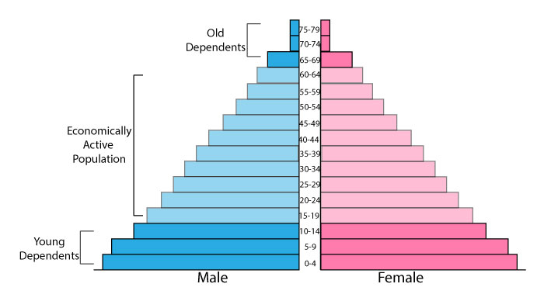

1. Young Population Dominance (Expansive Pyramid)
- Population Pyramid: Broad base, narrow top
- Characteristics: High proportion of children, high birth rate, low life expectancy
- Economic Implications:
  - High dependency ratio → fewer workers per dependent
  - High expenditure on health, education, and childcare
  - Limited savings and investments, which can slow economic growth
- Example: Many developing countries like Niger or Afghanistan

2. Working-Age Population Dominance (Transitional Pyramid)
- Population Pyramid: Wider middle, tapering top and bottom
- Characteristics: Large working-age group (15–64), declining birth and death rates
- Economic Implications:
  - Low dependency ratio → more workers per dependent
  - Potential for economic growth if employment opportunities exist
  - Increased savings and investment → demographic dividend
- Example: China in the 1990s–2000s

3. Elderly Population Dominance (Contractive Pyramid)
- Population Pyramid: Narrow base, broad top
- Characteristics: Low birth rate, high life expectancy, aging population
- Economic Implications:
  - High old-age dependency ratio → more retirees per worker
  - Increased health care and pension costs
  - Potential labor shortages and slower economic growth
- Example: Japan, Germany

Table Representation
Population Type | Pyramid Shape | Key Feature | Economic Impact
Expansive | Broad base | Many children | High dependency, slower growth
Transitional | Wide middle | Many working-age | Low dependency, demographic dividend
Contractive | Narrow base | Many elderly | High dependency, slow growth

Conclusion:
A balanced age structure with a higher proportion of the working-age population generally supports economic development, while a very young or very old population increases dependency and can slow economic progress. Proper policies in education, employment, and healthcare are essential to harness the demographic potential.

Demographic Transition Model (DTM)
The Demographic Transition Model (DTM) is a theoretical framework that explains the transition of a country’s population from high birth and death rates to low birth and death rates as it develops economically. It helps understand population growth patterns and the demographic changes that accompany economic, social, and technological development.

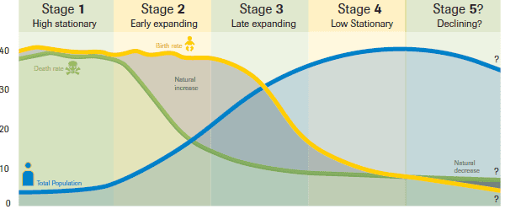
This model is typically divided into five stages, each representing a different combination of birth and death rates and population growth trends.

Stage 1: High Stationary
- Characteristics:
  - High birth rates and high death rates, often fluctuating.
  - Population growth is very slow or stagnant.
  - Population structure is generally young, with a wide base in the population pyramid.
- Causes:
  - Limited medical knowledge and poor healthcare.
  - Subsistence agriculture and unreliable food supply.
  - High infant mortality rates.
- Example: No country is currently in Stage 1; pre-industrial societies historically experienced this stage. Some remote tribal societies may resemble this stage today.

Stage 2: Early Expanding

Characteristics:
  - Death rates begin to fall due to improvements in healthcare, sanitation, and food supply.
  - Birth rates remain high, so population grows rapidly.
  - Population pyramid shows a broad base, indicating a high proportion of young people.
- Causes of Transition from Stage 1 to Stage 2:
  - Introduction of modern medicine, vaccination, and clean water.
  - Agricultural advancements improving food security.
  - Reduced incidence of famine and disease.
- Example:
  - Developing countries: Nigeria and Afghanistan in the mid-to-late 20th century.
  - Developed countries: England during the Industrial Revolution (18th–19th century).

Stage 3: Late Expanding
- Characteristics:
  - Birth rates begin to decline, while death rates remain low.
  - Population growth slows but remains positive.
  - Population pyramid starts to narrow at the base, indicating smaller family sizes.
- Causes of Transition from Stage 2 to Stage 3:
  - Urbanization reduces the economic benefit of large families.
  - Increased access to contraception and family planning.
  - Improvements in female education and employment opportunities.
  - Cultural shifts towards smaller families.
- Example:
  - Developing countries: India in recent decades.
  - Developed countries: France and the USA during the 19th and early 20th centuries.

Stage 4: Low Stationary
- Characteristics:
  - Both birth and death rates are low.
  - Population growth is very slow or stable.
  - Population pyramid becomes more rectangular, showing an aging population.
- Causes of Transition from Stage 3 to Stage 4:
  - Widespread use of modern contraception.
  - High levels of urbanization and industrialization.
  - Social changes such as delayed marriage and childbearing.
- Example:
  - Developed countries: Germany, Japan, and Canada in the late 20th century.

Stage 5 (Optional/Speculative): Declining Population
- Characteristics:
  - Birth rates fall below death rates, causing population decline.
  - Population pyramid shows a narrow base and a large elderly population.
- Causes:
  - Persistent low fertility rates due to lifestyle choices and economic pressures.
  - Aging population leading to higher death rates relative to births.
- Example:
  - Developed countries: Japan and Germany today.
  - Some argue that Italy and Russia are also entering this stage.

Factors Responsible for Transition Between Stages
- Economic Development:
  - Industrialization reduces dependence on children for labor, leading to lower birth rates.
- Healthcare Improvements:
  - Vaccinations, sanitation, and modern medicine reduce death rates, especially infant mortality.
- Education:
  - Education, particularly for women, reduces fertility rates and delays childbirth.
- Urbanization:
  - Urban life increases living costs and reduces the utility of large families.
- Cultural and Social Changes:
  - Shifts in family norms, marriage age, and gender roles affect birth rates.
- Government Policies:
  - Family planning programs and incentives (or restrictions) influence fertility rates.
- Technological Advancement:
  - Agricultural and industrial improvements reduce mortality and allow population stabilization.

Conclusion
The Demographic Transition Model explains how population patterns evolve as societies develop. In developed countries, transitions happened gradually with industrialization and improved healthcare, while in developing countries, transitions are often faster due to modern technology and globalization. Understanding these stages helps policymakers plan for education, healthcare, employment, and sustainable resource management in both rapidly growing and aging populations.

Plate Tectonic Theory
The Plate Tectonic Theory is a unifying concept in geology that explains the large-scale movement of the Earth’s lithosphere. It describes how the outer rigid layer of the Earth (the lithosphere) is divided into several large and small plates that float and move over the semi-molten asthenosphere beneath them.

Basic Concept
According to this theory, the Earth’s surface is not a single unbroken shell but consists of about seven major and several minor tectonic plates. These plates move continuously, though very slowly, due to convection currents generated by heat from the Earth’s interior within the mantle.

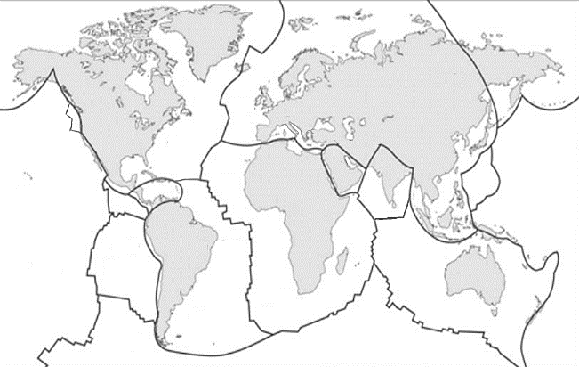
Major Plates

The major plates include:
- Pacific Plate
- North American Plate
- South American Plate
- African Plate
- Eurasian Plate
- Indo-Australian Plate
- Antarctic Plate

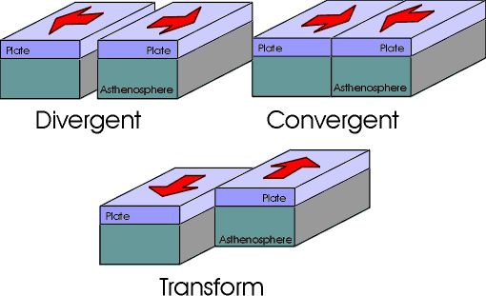
Types of Plate Boundaries

- Divergent Boundaries (Constructive)
  - Plates move away from each other.
  - Magma rises to form new crust.
  - Example: Mid-Atlantic Ridge.
- Convergent Boundaries (Destructive)
  - Plates move toward each other.
  - One plate may be forced beneath another, forming subduction zones or mountain ranges.
  - Examples: Himalayas (continental collision), Andes Mountains (oceanic-continental subduction).
- Transform Boundaries (Conservative)
  - Plates slide past each other horizontally.
  - Causes earthquakes but no crust is created or destroyed.
  - Example: San Andreas Fault (USA).

Forces Driving Plate Movement
- Mantle Convection: Circulation of molten rock in the mantle moves plates.
- Ridge Push: Gravity pushes the plate away from mid-ocean ridges.
- Slab Pull: The sinking of a subducting plate pulls the rest of the plate downward.

Evidence Supporting Plate Tectonic Theory
- Fit of Continents: Continents like South America and Africa appear to fit together.
- Fossil Evidence: Similar fossils found on widely separated continents.
- Seafloor Spreading: New crust formation at mid-ocean ridges confirmed by magnetic stripes.
- Earthquake and Volcano Distribution: Most occur along plate boundaries.
- Paleomagnetism: Magnetic patterns in rocks record plate movements over time.

Importance of Physical Geography in Environmental Management and Sustainability
Physical geography is the branch of geography that studies the natural features and processes of the Earth — such as landforms, climate, soils, water bodies, and ecosystems. It provides essential knowledge for understanding how the natural environment functions and how human activities impact it. This understanding is crucial for effective environmental management and promoting sustainability.

Understanding Natural Processes
Physical geography helps explain natural systems such as the water cycle, weather patterns, erosion, and soil formation.
- By understanding these processes, environmental managers can predict and mitigate natural hazards like floods, droughts, and landslides.
- It also supports sustainable land use planning by identifying areas prone to environmental degradation.

Resource Management
Knowledge of the Earth’s physical features aids in the responsible use of natural resources such as minerals, water, forests, and soils.
- Physical geography identifies the distribution and availability of these resources.
- This helps in managing them efficiently without overexploitation, ensuring their long-term sustainability.

Climate and Environmental Planning
Understanding climate zones and atmospheric processes enables better planning for agriculture, urban development, and disaster preparedness.
- It helps design climate-resilient cities and infrastructure.
- Provides data for climate change adaptation and mitigation strategies.

Biodiversity Conservation
Physical geography provides insight into different ecosystems and habitats.
- It helps identify ecologically sensitive areas and design protected zones like national parks and wildlife reserves.
- Understanding topography, soils, and hydrology ensures the protection of habitats and species diversity.

Land Use and Urban Planning
Topographic and geomorphological studies guide where and how human settlements should be developed.
- Helps avoid building in floodplains, unstable slopes, or erosion-prone areas.
- Supports sustainable urban expansion with minimal environmental impact.

Disaster Risk Reduction
By studying earthquakes, volcanoes, and other natural hazards, physical geography provides essential data for disaster preparedness and risk management.
- It allows for mapping hazard zones, developing early warning systems, and planning evacuation routes.

Supporting Sustainable Development Goals (SDGs)
Physical geography contributes directly to several SDGs, including:
- Goal 6: Clean Water and Sanitation
- Goal 13: Climate Action
- Goal 14: Life Below Water
- Goal 15: Life on Land
Its insights support integrated environmental policies and sustainable land and resource management.

Summary
Physical geography forms the scientific foundation for understanding the Earth’s natural systems and their interactions with human activities.
By applying this knowledge, policymakers and environmental managers can develop sustainable strategies for resource use, hazard management, and conservation — ensuring a balanced relationship between people and the planet.

Scope of Human Geography in the Modern World
Human geography is a vital branch of geography that explores the complex relationships between people and their environments. It focuses on how human societies develop, interact, and adapt within physical spaces, and how these interactions shape the world. In the modern era, where globalization, technological change, and environmental challenges dominate global affairs, the scope of human geography has grown remarkably wide and significant.

Population and Demographic Studies
A major field within human geography is the study of population and demographics. It examines patterns of population growth, migration, and distribution to understand how people organize and utilize space. This knowledge supports governments and organizations in planning for housing, healthcare, education, and employment. Understanding population dynamics also helps ensure that development policies align with regional needs and sustainable resource use.

Urbanization and Settlement Development
Human geography provides crucial insights into the processes of urbanization and the formation of settlements. As cities expand and rural populations decline, understanding how and why settlements evolve has become essential for sustainable planning. Studies of settlement patterns help address modern challenges such as overcrowding, pollution, and resource scarcity. The discipline guides urban planners in designing more livable, efficient, and environmentally balanced spaces.

Economic Geography
Economic geography focuses on the spatial organization of economic activities such as industry, agriculture, trade, and services. It investigates how these activities are distributed across regions and how they shape patterns of development. In today’s globalized economy, economic geography helps explain regional disparities, global trade flows, and the rise of industrial and technological centers. The knowledge it provides is critical for balanced economic growth and regional development planning.

Cultural Geography
Cultural geography examines how human culture—beliefs, values, language, and traditions—interacts with and shapes the physical landscape. It highlights how cultural diversity influences architecture, land use, and social organization. In a rapidly globalizing world, cultural geography promotes cultural understanding, heritage preservation, and identity awareness, helping societies value and protect their cultural uniqueness.

Political Geography
Political geography studies the spatial expression of political power, boundaries, and governance. It explores how political decisions shape territories and influence international relations. In a world marked by geopolitical tensions, border disputes, and globalization, political geography plays an important role in understanding global politics, diplomacy, and regional cooperation. It also helps policymakers develop peaceful and sustainable governance strategies.

Environmental and Social Interactions
Human geography also investigates how human activities affect the environment and how environmental conditions, in turn, influence societies. This branch contributes to sustainable resource management, climate change adaptation, and environmental conservation. It encourages development that balances economic progress with ecological stability, ensuring the well-being of both people and the planet.

Technological and Spatial Analysis
With technological advancements, human geography has embraced tools such as Geographic Information Systems (GIS) and remote sensing to analyze spatial data. These technologies allow geographers to map urban expansion, monitor environmental change, and manage disasters with greater precision. Such spatial analysis is now central to policy-making, infrastructure planning, and sustainable development projects.

Globalization and Development
Human geography provides the framework to understand globalization and its impacts on economies, societies, and environments. It examines how global networks of communication, trade, and migration are reshaping local and regional identities. The discipline supports strategies for reducing inequalities, promoting sustainable development, and fostering cooperation in an interconnected world.

Conclusion
The scope of human geography in the modern world is broad and dynamic. It connects society, economy, and environment through an integrated understanding of space and place. In an age of rapid urbanization, environmental degradation, and global interdependence, human geography provides essential insights for sustainable and inclusive development. Its role in guiding policy, planning, and research makes it one of the most relevant disciplines for addressing the challenges of the twenty-first century.

